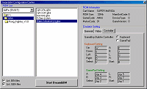
As you might have guessed from the name, DreamGBA is from the author of DreamGBC. It runs several games already, including Castlevania and Tactics Ogre - with sound! Just like DreamGBC the emulator is a command line application which is started by a loader application.
A nasty problem of this emulator is that it requires the original Gameboy Advance BIOS to run. The GBA.BIOS file included with the emulator is a 0 byte dummy file and won't work.
Just like the Playstation BIOS it is not legal to distribute the real GBA BIOS (so you won't find it on this site) and just as hard to find. However using Google I was able to find it anyway. Just don't be afraid to search sites not in English as I found it on a Polish emulation site.
Note: If you get an "DLL not found" message when running the DreamGBA loader it means you don't have the Visual Basic 6 Runtime modules installed. You can download them from Microsoft.

